Minimum Spannig Tree
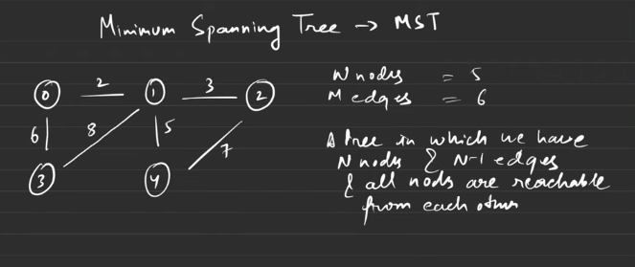
Below are the spannig trees
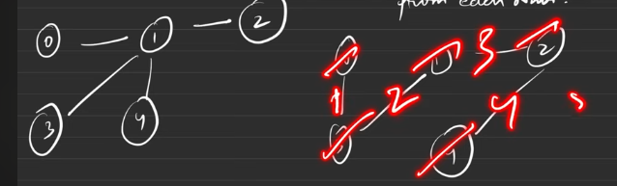
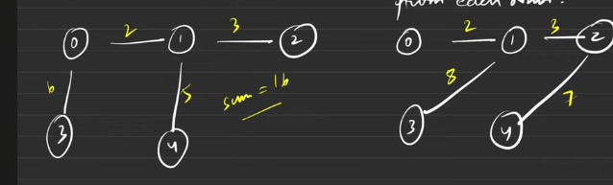
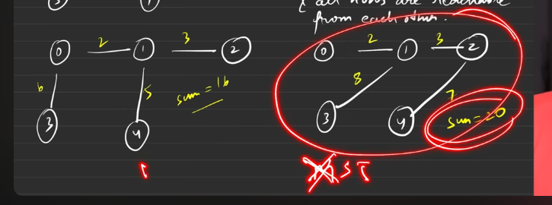
Ex:
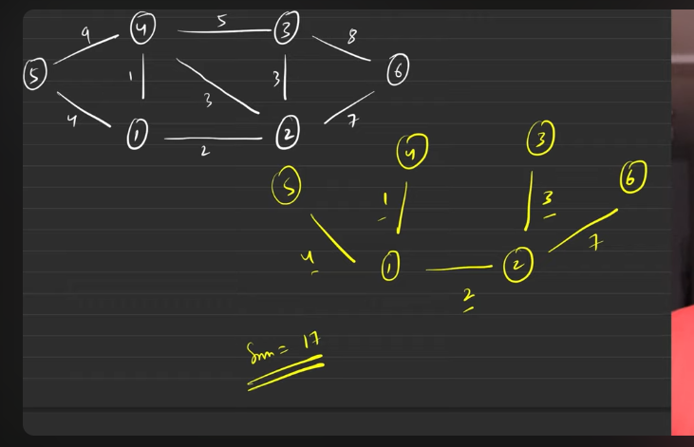

PRIMS ALGO
Make the inital configuarations as the priority queue insertion with {wt, node , parent}- this to be pushed with the 0 as the inital node.
Keep the visited array to know which are all the nodes are already visited.
- Pop the node PQ, and check for all the adjacent nodes, if the node is not visited then do not entered the visited node into PQ.
- With the distance from the current node to the target node, { entry of PQ }.
- Keep teh sum tracked and edge to be pushed to vector.

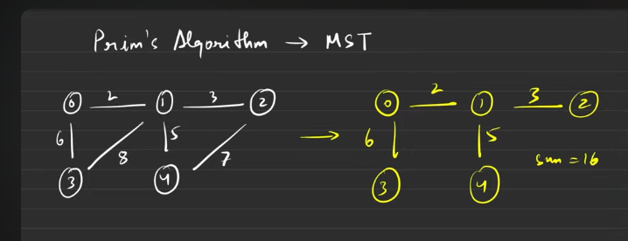
Prims algorithms helps us to find the MST
Init config:
- Priority queue
- Visited array
- A vector which holds the mst
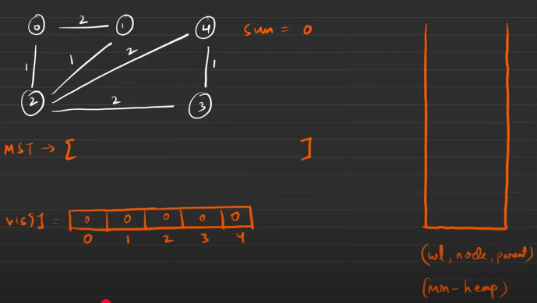
The inital configuarations to be made is this, we need to push those things initial configuarions into the min heap. If parent is -1 then it is the start node.
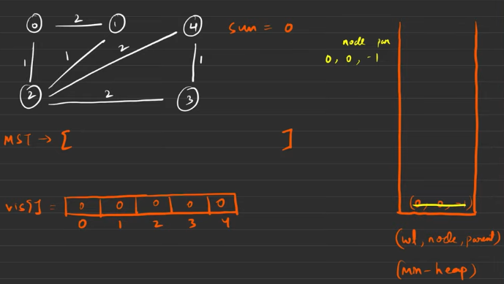
Whatever it is related to the popped noed from the min heap, that will be pushed into min heap. Mark the popped as 1 in visited for the node.
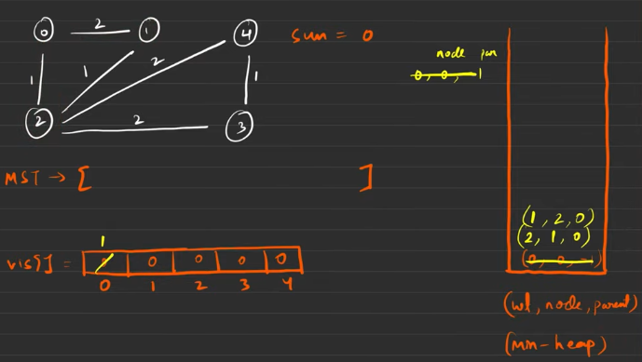
Now pop and make the visited[index] =1 then add the edge to MST.
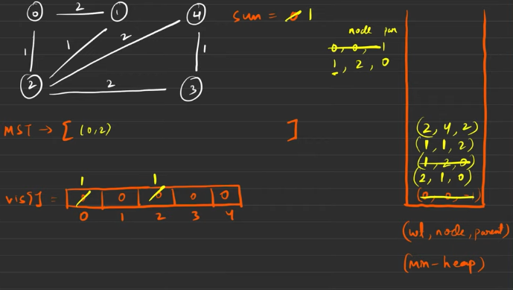
When the neighbour is visited then it is not advised to not yo keep the data into the priority queue.
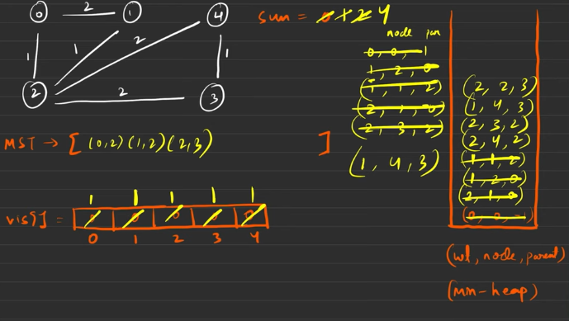

In question if they are asking for the MST keep the parent too. If the MST s not asked then it is better to go with {wt, node}.
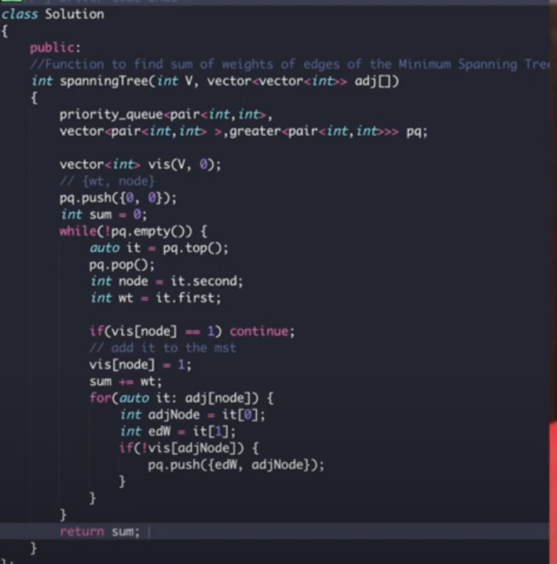
In this:

The above edge was ignored (0->1,2)because of the greedy nature of PQ
Intuition is greedy.
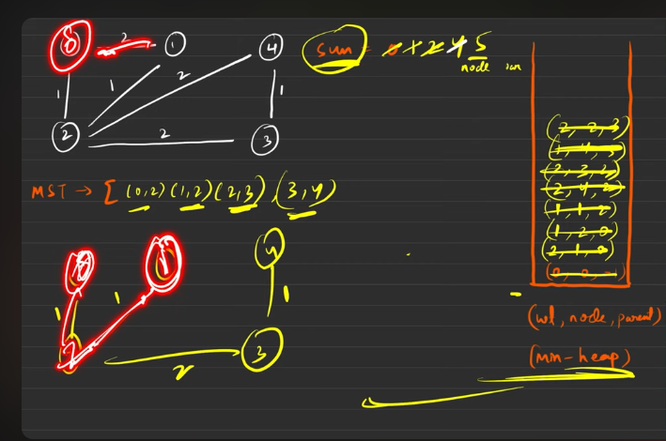
Time complexity:
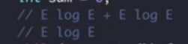

Disjoint Set

To say that a particular node is a part of the tree or not, we had to do DFS or BFS and we were getting that to know in O(N) time complexity.
But to know whether a node belongs to the tree or not in Disjoint, then it is possible to know it in O(constant ) time.

Usually this is used in Dynamci graph, the graph which is used to change the configuarations everytime.

It gives 2 functions:
- FindingParent()
- FindUnion() by rank or by size

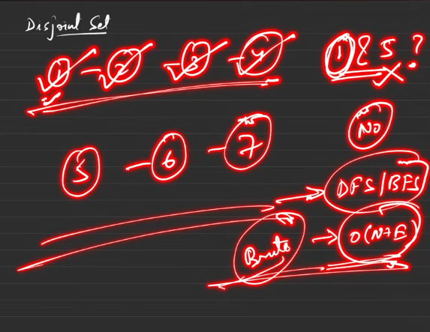

Dynamic graphs or how does the graphs configuaration is changing everytime?

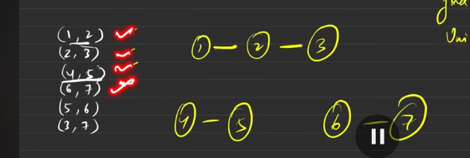
Initally only the nodes are present,
When half of the edeges are connected then and some one asks aout the whether these things are connected ro not?
Still the graphs are changing themsleves by making the edges between the nodes everytime, till not completley filled and suddenly someone asks the question regarding th configuarations then this is called as the Dynamic graphs. But this is how the graph is formed

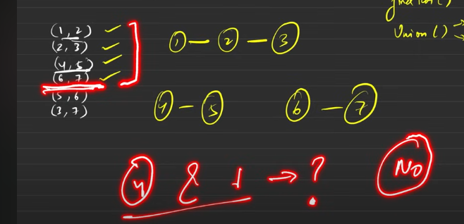
4 and 1 is not in teh csame component? No
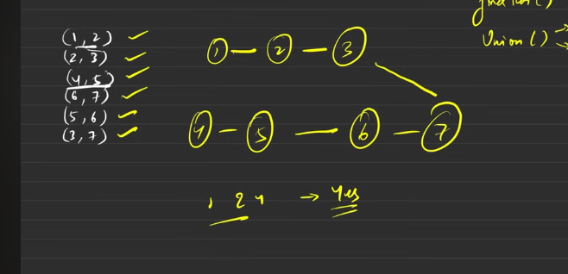does 1 and 4 belongs to the same component? Yes this is called the dynamic configuarations
It hhas 2 functions:
- findParent()
Union can be done in 2 ways:
- Rank
- Size

Initialaisations;
Rank – we declare the size of rank with the size of the nodes in it.
It says how many number of child nodes are present under it, currently it is 0 , hence all 0s.
Parent array: All elemnts are parent of itself.
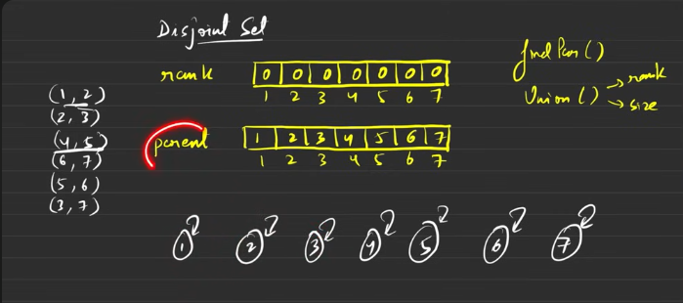

Psuedocode:
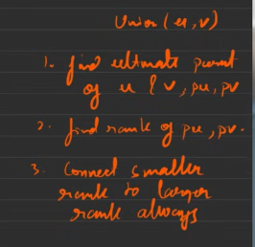
- Find the ultimate parent
- Find the rank of ultimate parent node(top guy)
- Connect the smaller rank to the larger rank, if same rank we can connect anyone with anyone
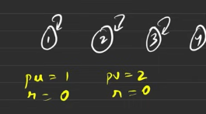
Currernly we can connect anyone with anyone

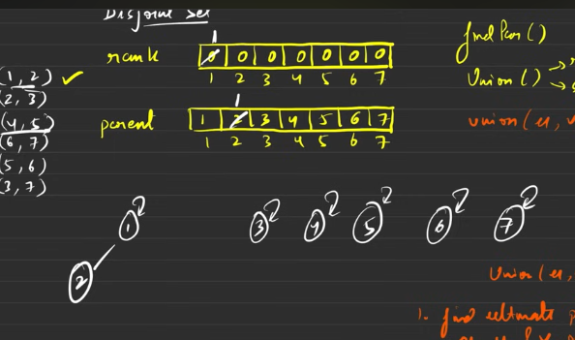
The rank of the node 1 is changed to 1 and parent of 2 is 1 right now.
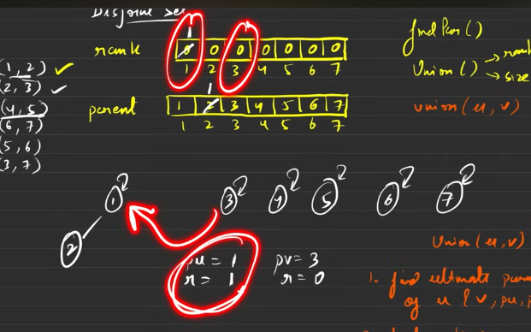
Since the rank of 3 is 0 and the ultimate parent of 2 is 1 and its rank is 1, hence the lower rank one is doced with the higher rank .

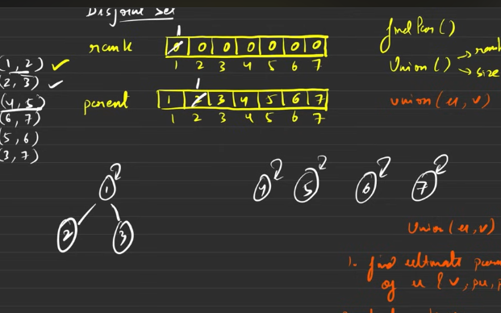

This goes on
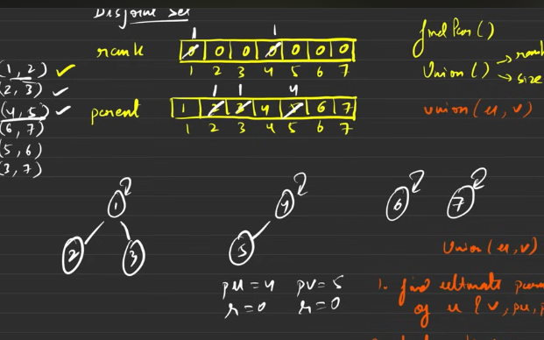
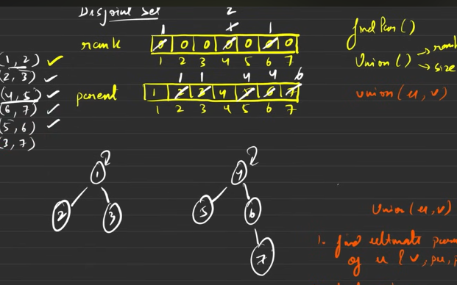
Does 1 and 7 belongs to the same compnent?
This is where we will be looking findParent() is used -

This must return the ultimate parent of each and every node. If the 2 nodes ultimate parent are same then yeah, both have the same component.

Hence maximum time tae uing the above is O(logn ), to know the answer in constant time, then path compression
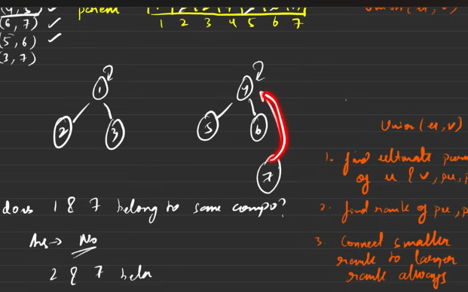
The red is path compression
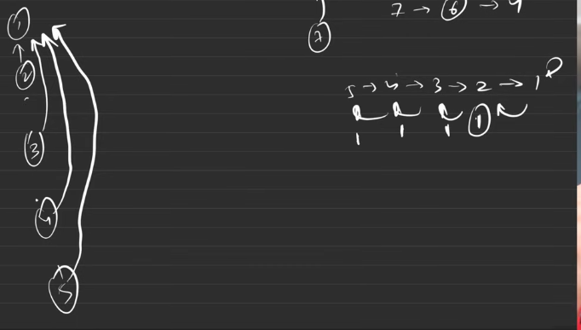
This is connected to 1.
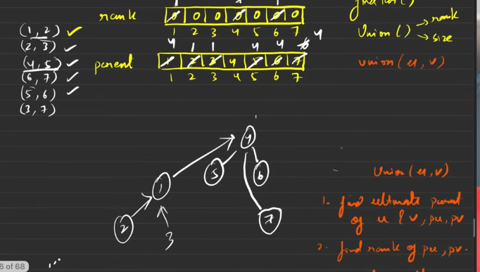
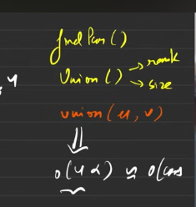

Find parent’s psuedocode
The below is how the code is looking
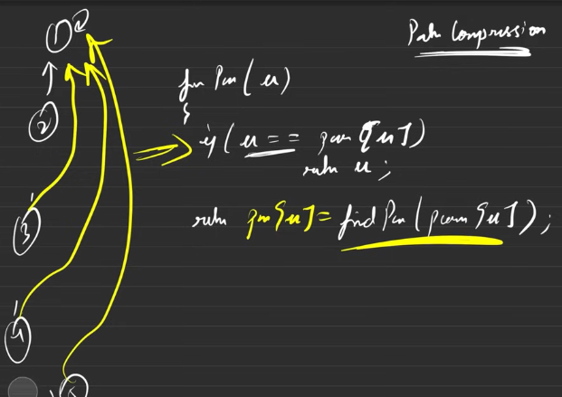
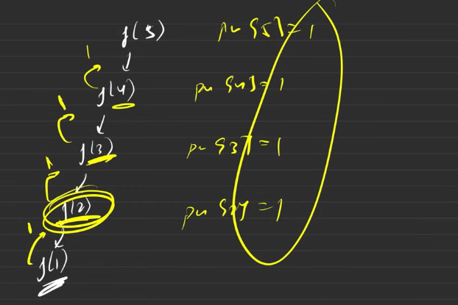
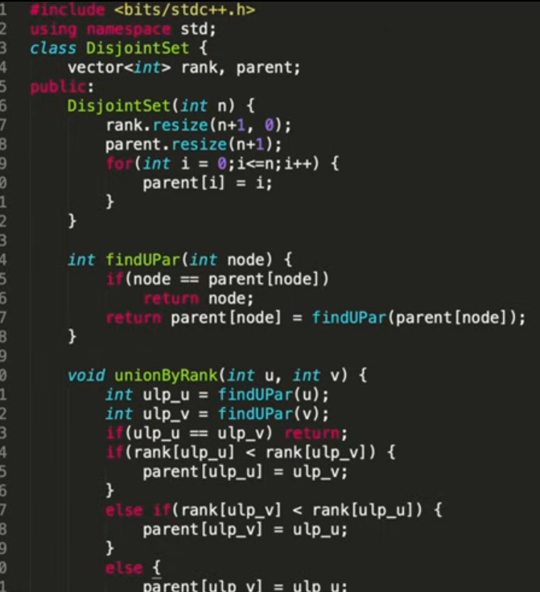
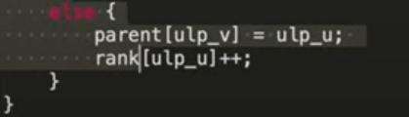

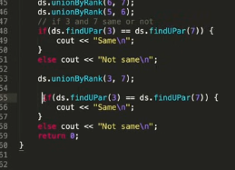

Why connect smaller to larger?
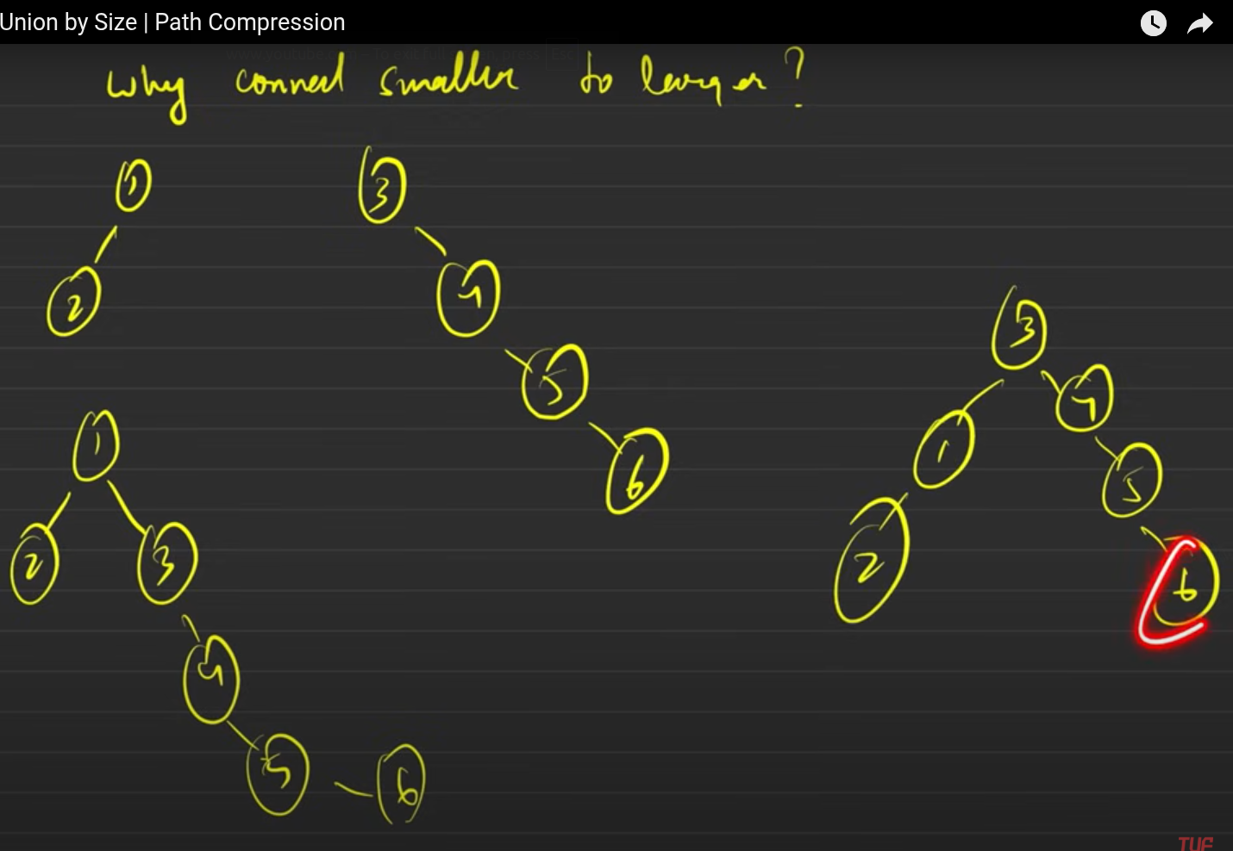
Thee starting 2 are the nodes/treees/ graphs
The lower one are resultant of the union.
To the left side down, the righer rank is connected to the low rank, so the time taken to find the parent is higher when compared to the down right.

The lower height is produced because of the lower rank is connecetd to the higher rank.
Hence the travelling time needs to be smaller as possible.
The reason why we do not use the union by height because after the path compression the height of the graph becomes small and the hieight will be altered. But the size remains constant, before and after the path compression, hence we are going to use the union by size.

Union By Size

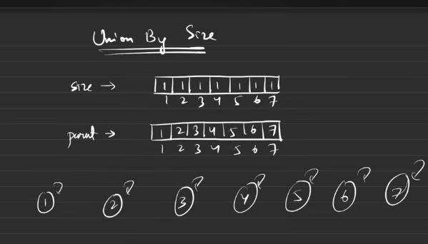
Initial config,
Need size vector= all the elements = 1, for all the elemnts in the size, parent vector = all are parent to themselves.

The edges will be given, we need to dock the graph elements nodes one by one.
Everytime we dock the smaller sized element’s parent will be docked to the higher sized node. The higher sized node’s size will be incrased by the value of the dock element.

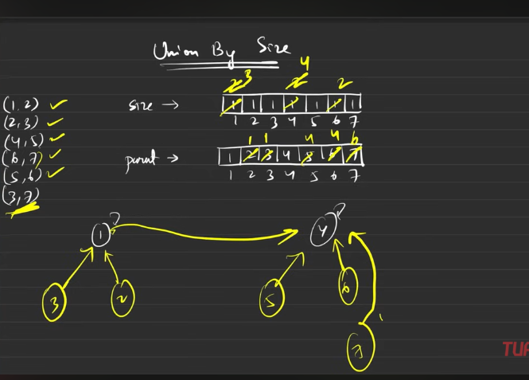

Bwlow is the newfunction that shall be inserted in the previous class.
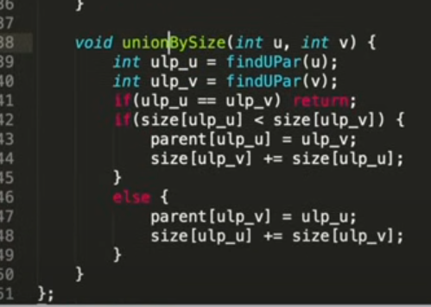

Remember do not use both the rank and size by union in combination

Kruskals Algo

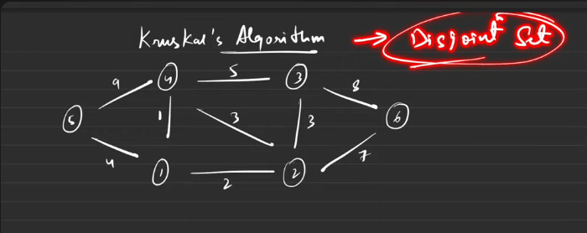
This algo is used to find the MST.

Step 1 : Sort all the ede weights in ascending order

Procedure:
Keep taking the edges from the sorted one by one.
Check whether the element seen is having different ultimate parent, if so, then union those 2 , by making the weights summation to MST. If they are having the same up then it is not considered for union, because making the union will make the cycyle.

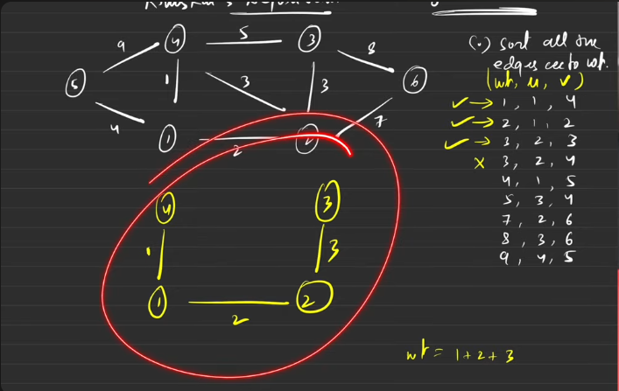
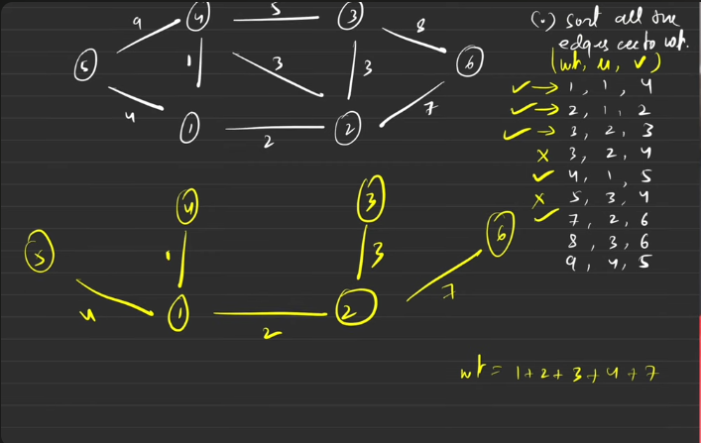
By default the edes are undirected , hence it has 2 sided edge, but this disjoint set i going to consider 2wice considered edge only once. Hnece while preparing the sorted vector , keep the data only once.

You try to code it first then check how accurate you are .

Number of Provinces

It is about finding the number of connected components.
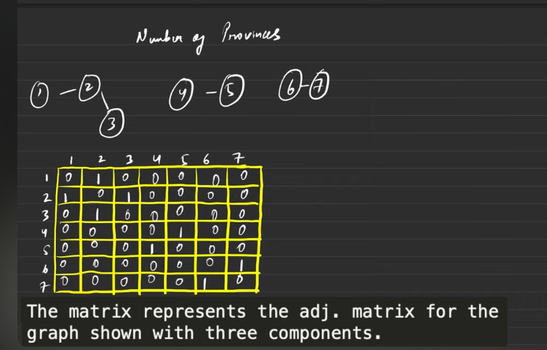
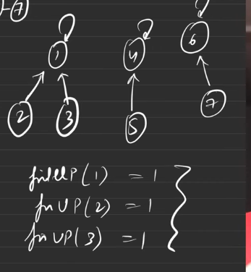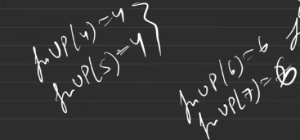
If I find the number ditinct bosses or super parent then it is nothing but the number of provinces.

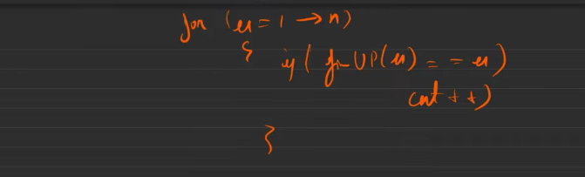

You code it .

Number of Operations to Make Network Connected

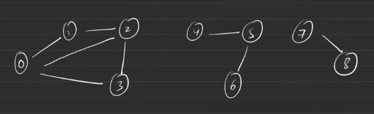

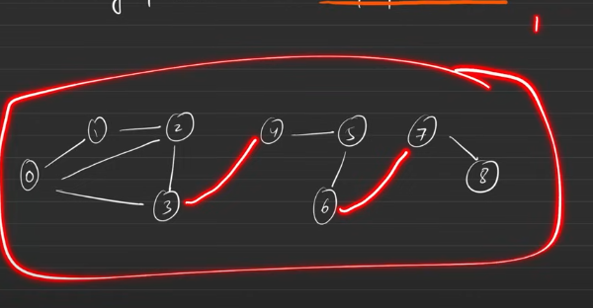
When you are connecting it from one component to another component there shall not be any imaginary edges, but you need to remove one edge from teh existed and then connect that between the components.

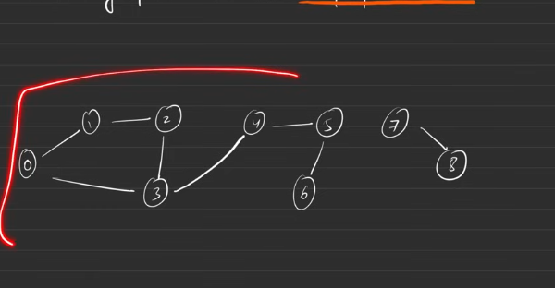
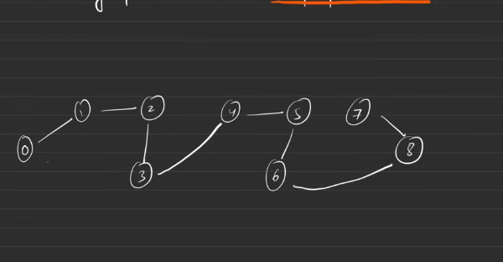
Hence we needed 2 edges that need to be removed in such a way that , connnected should not be disconnected.

Hence

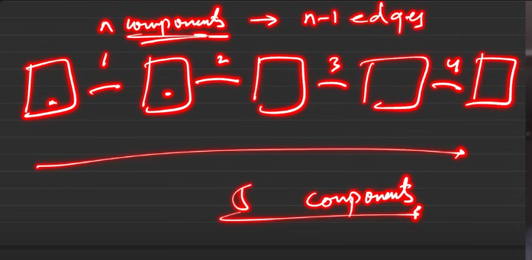
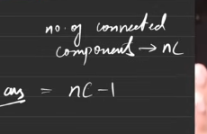
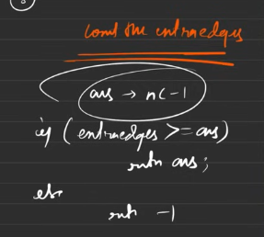
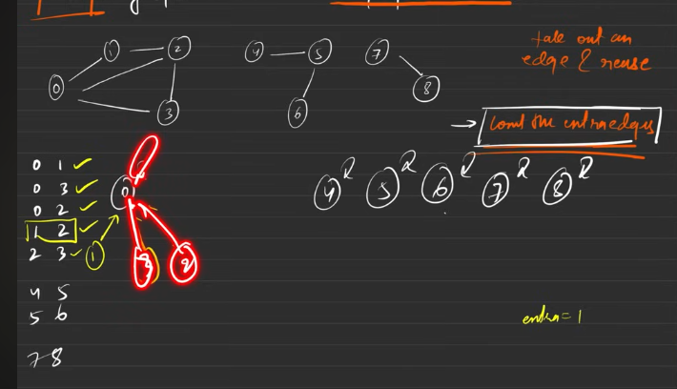
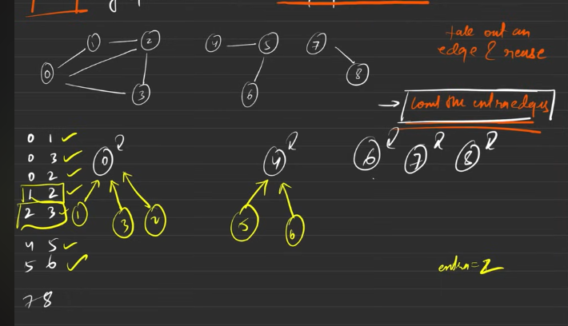

2 main things to be computed here:
- The number of extra edges we have
- The number of components

the Minimum number of operations needed is :
- The number of components -1. These manu number of edges to be aded
Number of extra edges:
- Start with the disjoint set.
- When the parent of the 2 different nodes are different then we are going to make the union of those nodes.
- When we have the 2 different nodes ultimate parent is one and the same it is nothing but nodes are already connected and the edge that is to be inserted is extra edge, just count it.

Number of components:
- When the nodes parent are they themselves the count shall be increased, wih says the number of components.
- If the ans from the above is more than or equal to number of compoents -1 then we will be returning the (number of compoents -1) else -1 will be returned.

You can code it.

Accounts Merge

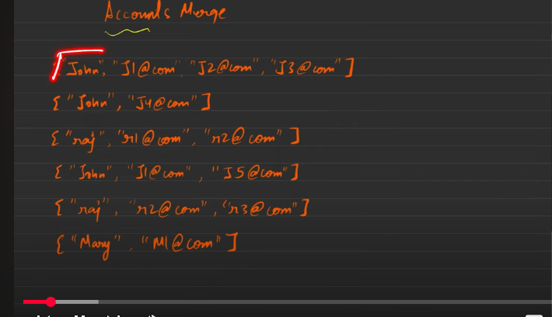
1st and 2nd they have the same name, but they have different values in them, hnce they are different from each other, but 1st and4th they have same name and ine of the values in it is common , hence we will be merging those things together.
The new merged once will be like:
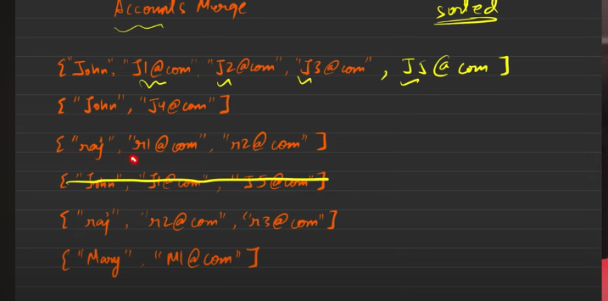
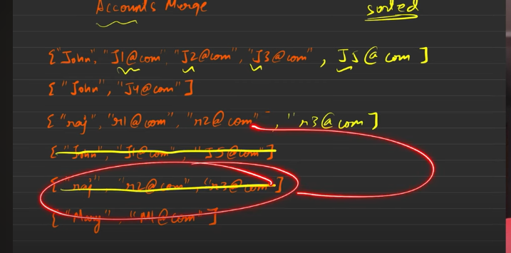

Finnally
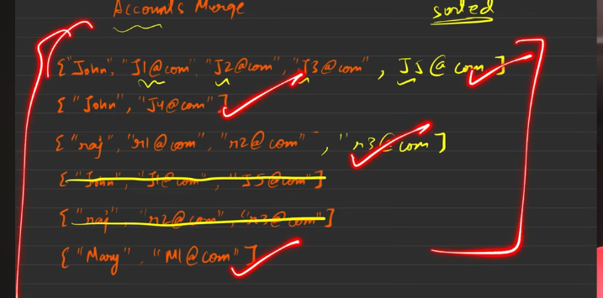
Returning , the names order does not matter, but the order in which the mail has been sent matters a lot.

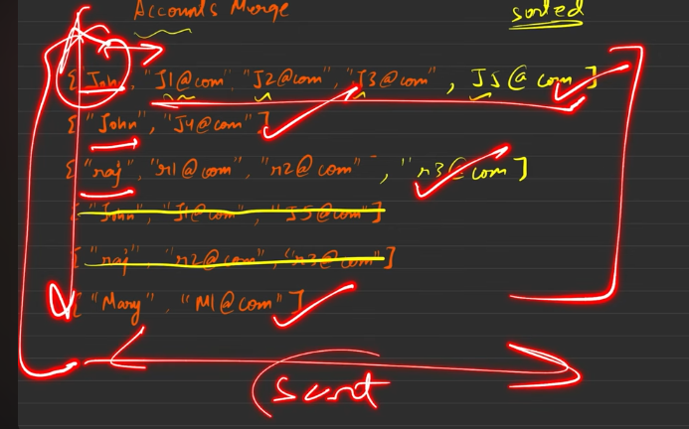
Understanding it:
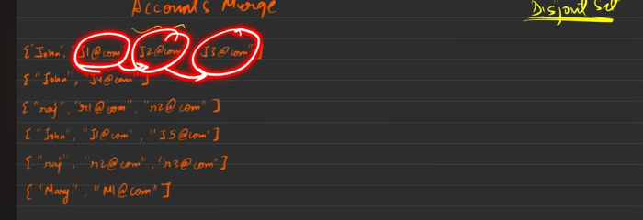
The email at the start saying that, somehow the values of the emails are connected with each other.
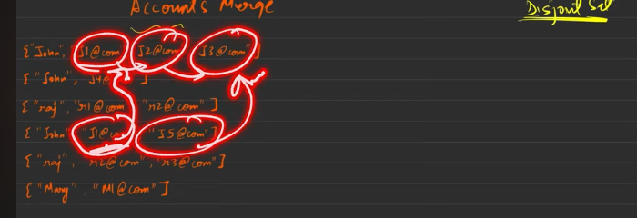
Observation: The connection between the elements is keep on changing dynamically, so this dynamic thing is done using the disjoint set , every stage some one is connecting.
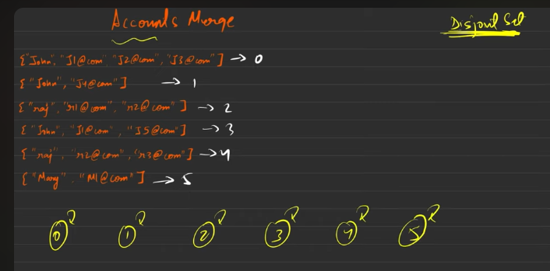

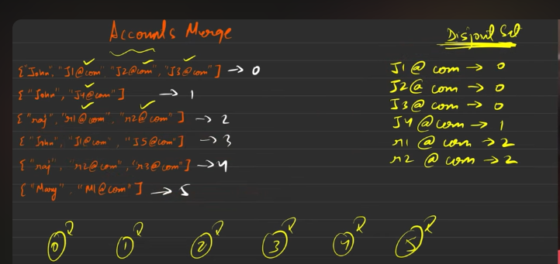
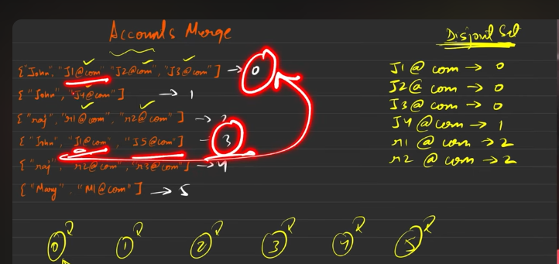
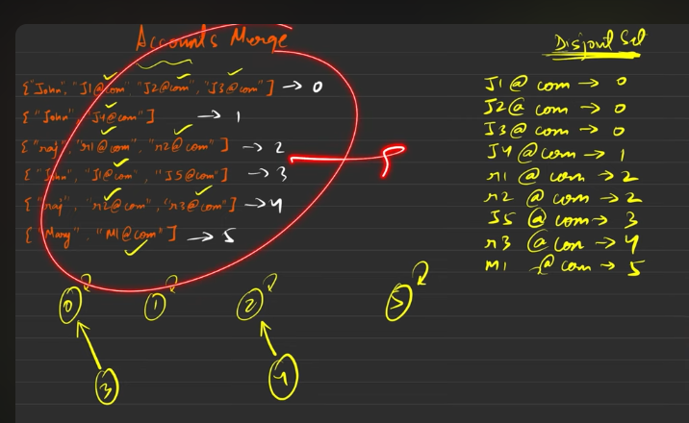
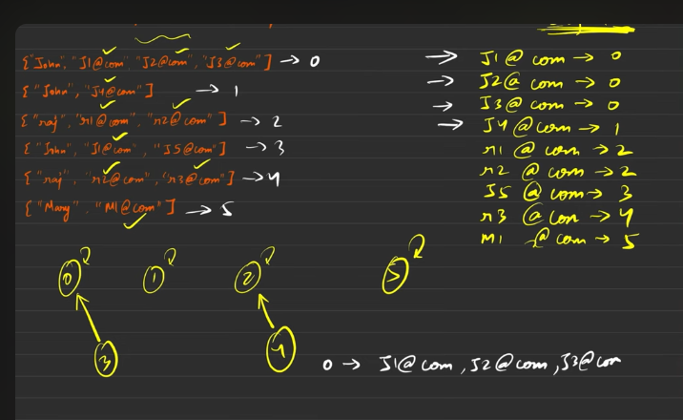
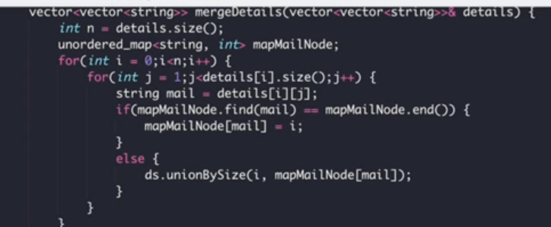
Even that 3 is mapped to 0.

The left extreme, eamil to the node is done using above code.
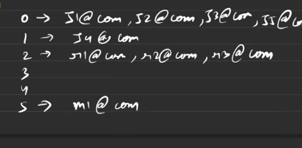
Then sort the values . After the first and then return teh value.

First consider all the different vectors as the node points. These node points are considered for making the disjoint set. Start conecting all the emails to node, one by one.
Eventually you will find the node which has common in their emails. So those nodes ill be combined together, made the union, the current ones as the child of ultimate parent.
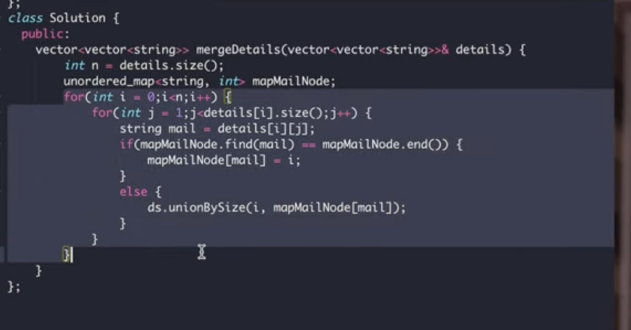
Please code, else yo are done

Number of Islands - II - Online Queries

We can mak the island only by shsring thesides with each other.

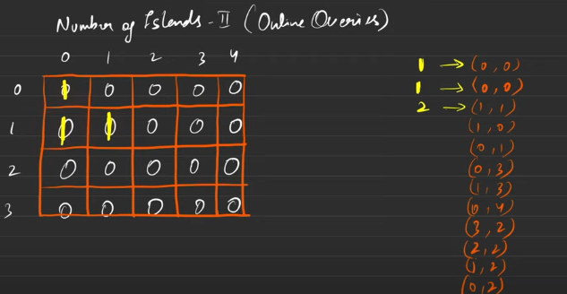
The ones here ones going to share the side with each other, hence all tehhings are mapped as one island
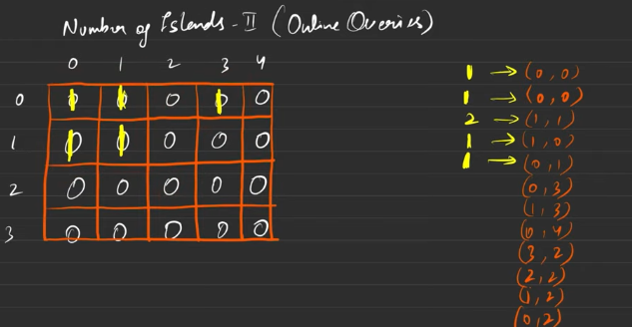
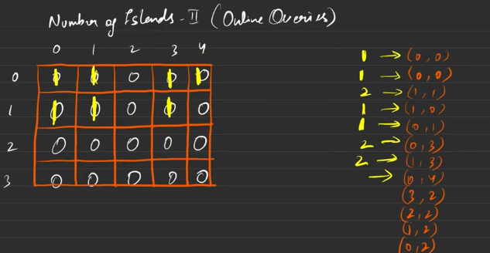
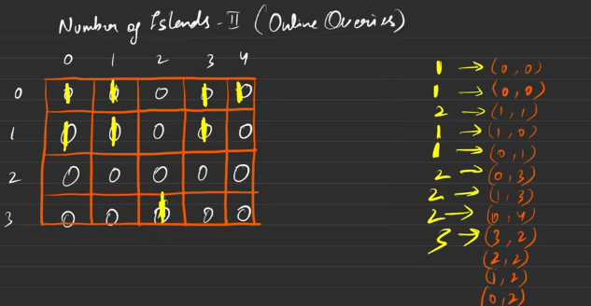
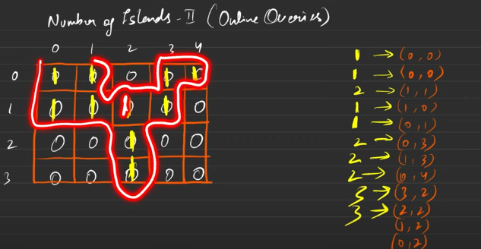
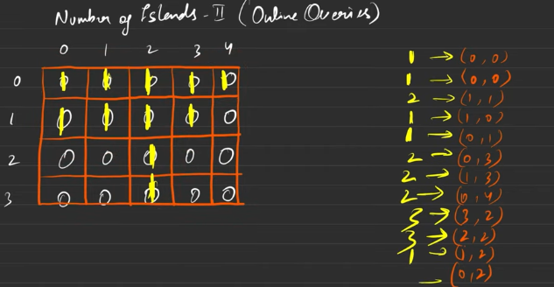
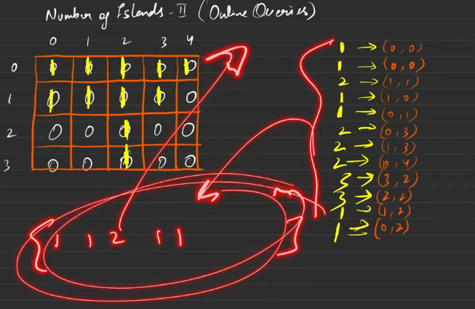
This to be shared

Dynamic garphs, after placing each and every eleemen in the array the characteristic of the array changes.
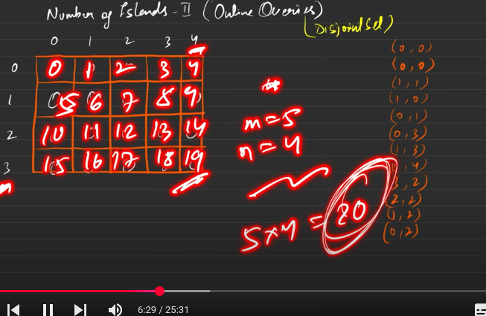
Then each and every eloements n this is acting like node

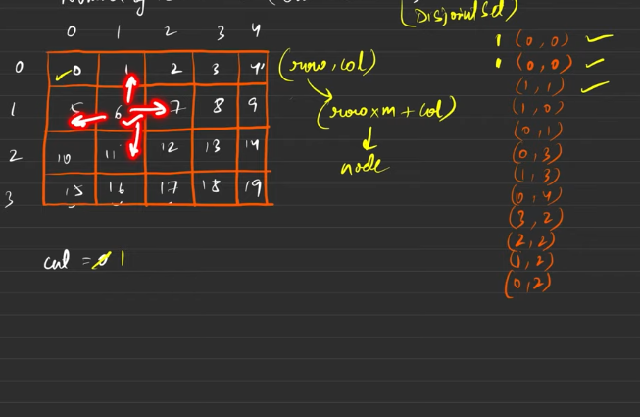
6 does not have any island in any side, sides = {left, right, top, bottom}, hence this will also contribute to the count , the count will be incremented by 1.
Hence
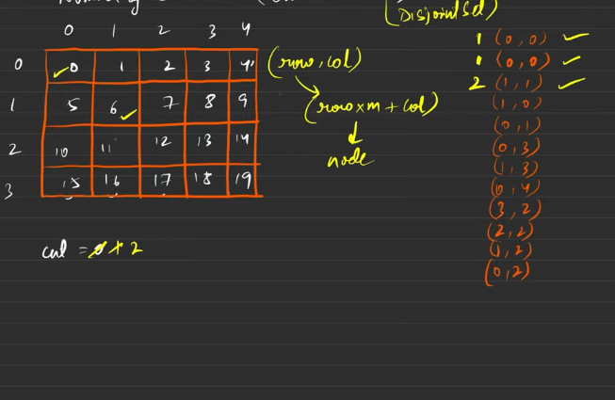
The node 5 would have been contributed to count if any point is not there in the sides/sourrounded by any one.
Hence this reduces the count by 2.
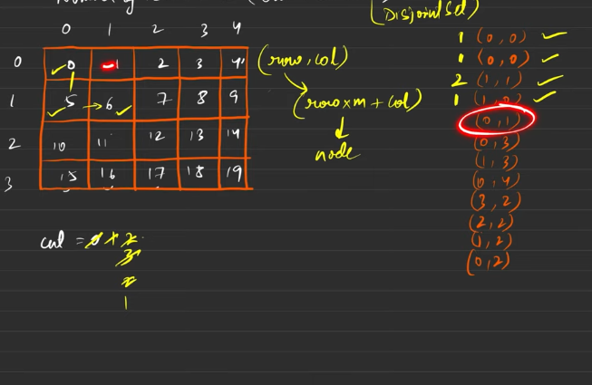
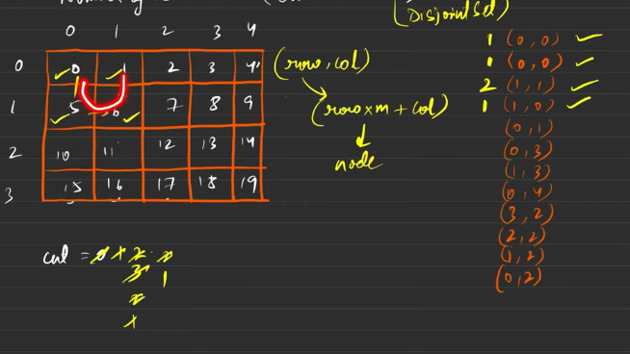
Finding ultimate boss is the key . Just keep checking for the present answer
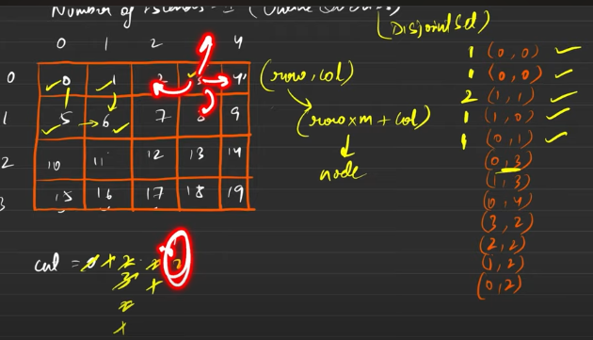

When marking it as present incrase the count by 1, but when you see the wall nearby then decarese the count by 1.
When we make the entry we increase the count by 1. But when you see there is some in the 4 directions then we reduce the count by one.

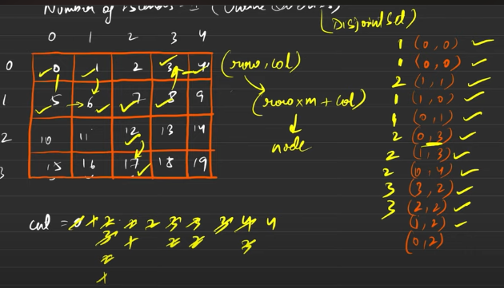
When it is seen in any one in any 4 directions, while making the traversing the count has to be decremented by 1.
When it is already connected there is no need to connect it again, only when we are traveling on any one of the directions, if found the ultimate boss is not the same as mine then we will connect this to those.

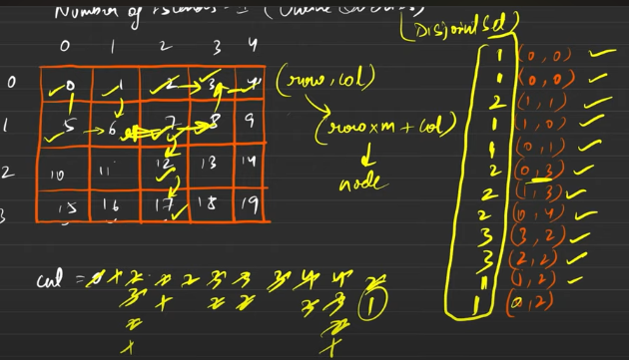
Hence all the values which is makred in the box shall be retunred as answer.

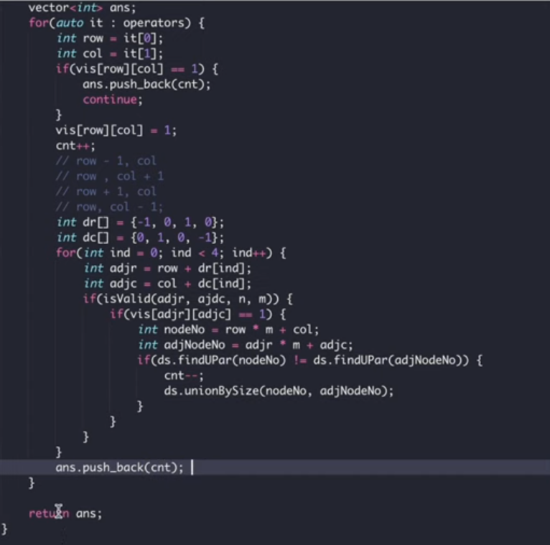

Making a Large Island - DSU

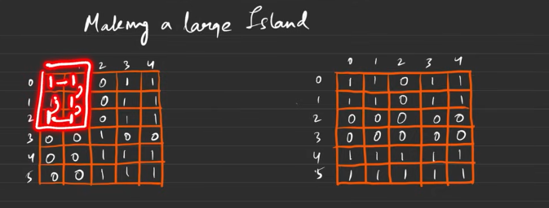
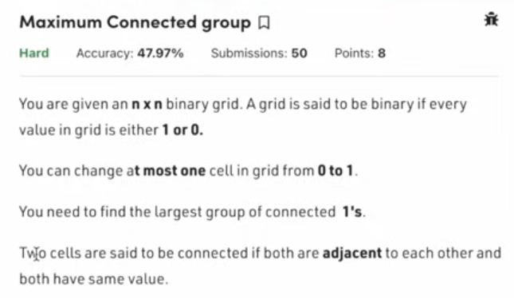
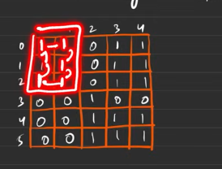

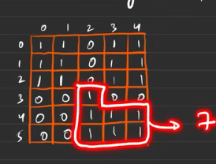
Till now the maximum that has been seen is 7
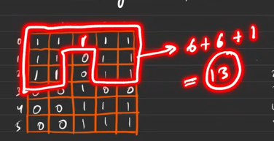
By making / chnaging from 0 to 1 , the maximumwhat we can get is 13.
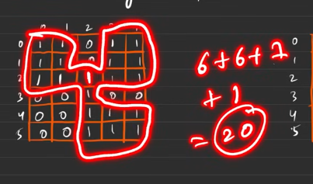
This is the largest we can get when only one bit is changed , the maximum area seen is in is 20 because of 1 bit changed.
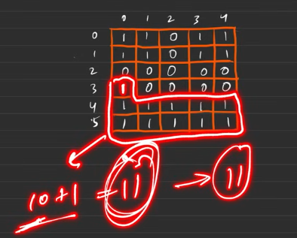
This shows that there is no need to connect the component to component, we can connect the side wise.

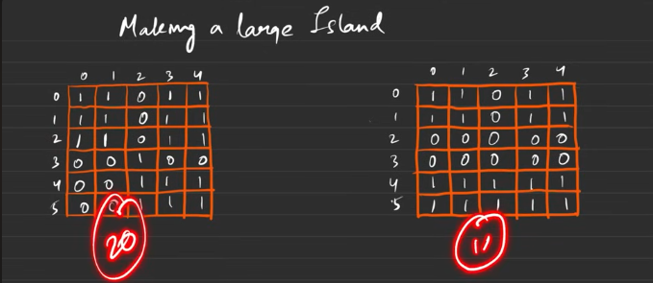
Hence the maxmimum can be seen is 20 .

Observation: Since there is dynaimic changes can be seen, by intrduction of soething new thiings are generated, the status keep changing by the introduction of the new bit. Hnec this can be handled using the disjoint set.
But we have the matrix with us , how can we make the nodes out of it?
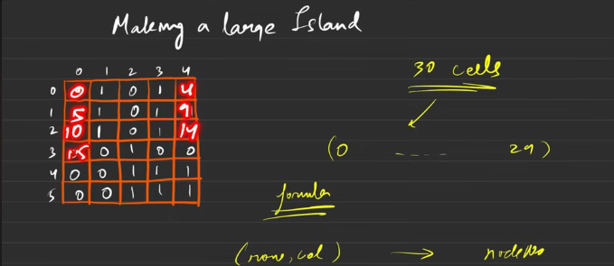
The starting ones are represented with the mutliple of 5. Thence the values are made addition with the new column .
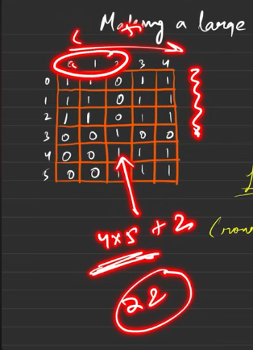
Converting from the matrix to node
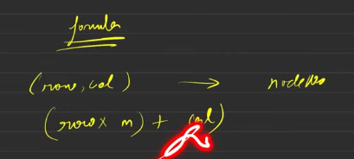
Do the union by the size for all the connecetd components
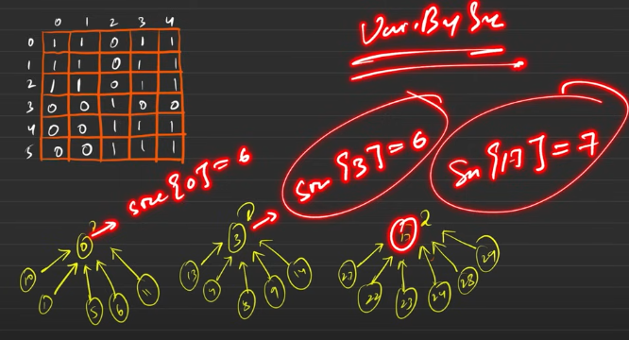
Once afer traversing all the nodes using union_by_size(),
Now start traversing the whole matrix and mark the once which are having 0. For those try to connnect to the components that are nearby and check which is having the maximum count.
The edge case:
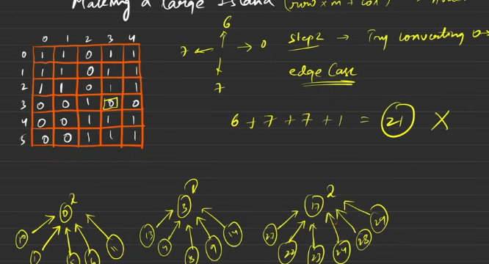
Hence to avoid these kind of errors keep the set in between and keep finding it using the union by size
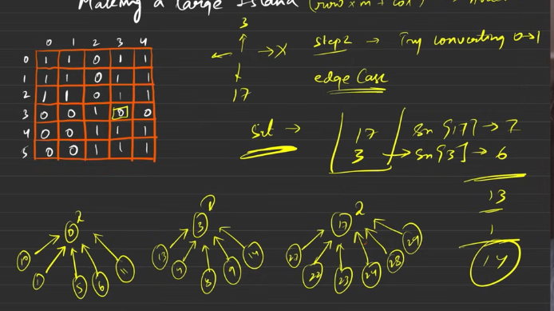
After traversign to all teh adjacent nodes it gets to know that these many number of adjacent boss’s size to be added .
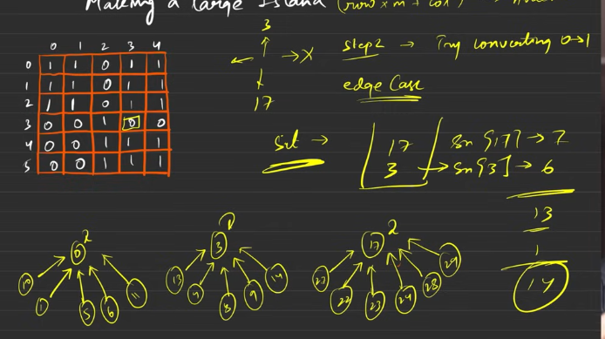
Psuedo code:
- Traverse array elements, and make the connecetd components using the unionBySize().
- Then strat traversing the array again , wheerever there is 0 is seen chec the adjacent is one or not, if so add the ultimateParent of the adjacent to set data structure.
- Then after traversing with all the zeros, now start traversing the set , whatever the size generated by the ultimate [arent will be added finally, this is done for all teh zeros and maximum will be stored and retunred.

Most Stones Removed with Same Row or Column

You can remove stone if it is going to share the stone either in the row or in the column.

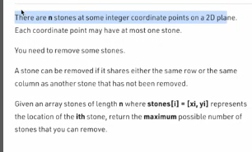
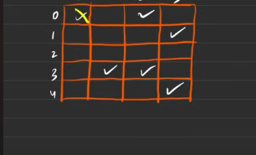
This stone does not have any stone in the column. Hence this can be removed.
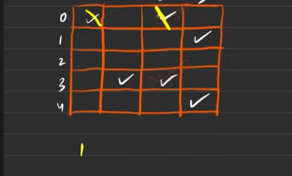
Since the second one has teh stone in teh column we can remove the 2nd stone.
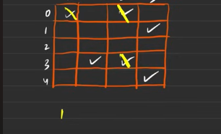
The third ones row has teh stone in it, so the stone can be removed.

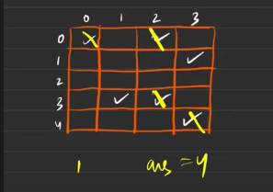
4th stone can be removed too.

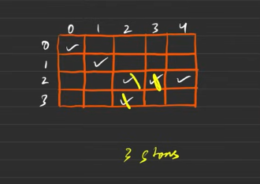
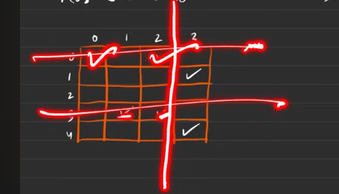
This is seen as the
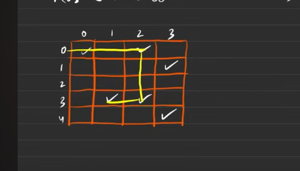
4 stone whcih are connected
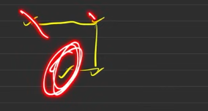
From thos e can remove the 3 stones but we canot remove the last one, because there is chance that it may not work well.

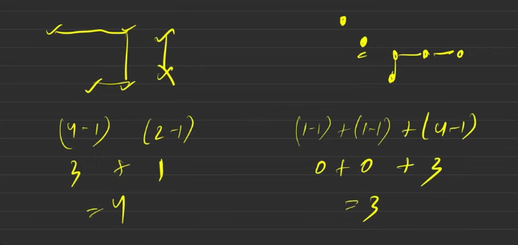
This is falling into connecetd components.

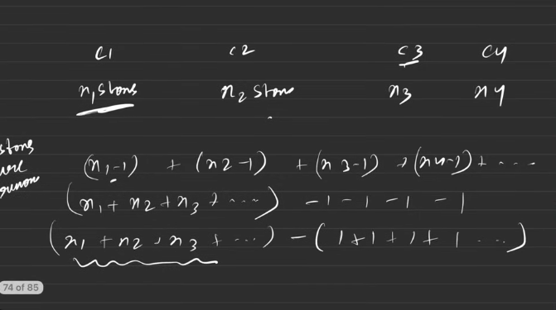
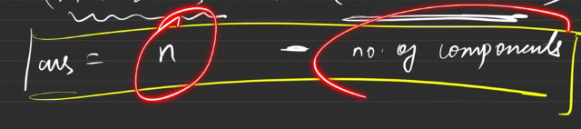
When you are speakign abut connecting teh components, then you are making use of the Disjoint set data structure.

